Techniques for Taking Pictures of Learning Videos in Learning Media

Day Ramadhani Amir
Information Technology Education, Faculty of Mathematics and Natural Sciences Education, IKIP PGRI Bojonegoro, Bojonegoro, Jawa East Java, Indonesia
Email: day.ramadhani@ikippgribojonegoro.ac.id

Abstract
This research aims to find out an explanation of video shooting techniques in learning media in the form of learning videos. This type of research uses a qualitative descriptive research approach. This research uses a literature study method from various journal literature and books which can strengthen material about video shooting techniques. The data collection technique in this research uses library research and internet searching to find supporting data or information. The results of the research show that the learning video shooting techniques in the form of Extreme Long Shot, Very Long Shot, Long Shot, Knee Shot, Medium Shot, Medium Close Up, Close Up, Big Close Up, Extreme Close Up and Low Angle, Eye Level, High Angle are correct and in accordance with applicable rules.
Keywords: Learning Media, Learning Video, Type Shot, Camera Angle

This work is licensed under a Creative Commons Attribution-NonCommercial 4.0 International License.

INTRODUCTION
Humans endeavor to alter their behavior and acquire information via education in order to improve both their own lives and the lives of others in society. According to Parwanta in Amir (2024) Education is a deliberate and planned attempt to create an environment that is conducive to learning and the learning process. Students actively develop their potential in education to have religious spiritual strength, self-control, personality, intelligence, noble morals, and skills needed by themselves, society, nation, and state.
Education is an interactive process that aims to help pupils reach their full potential via teacher-student contact. The process of learning is the assistance that educators provide to pupils in order for them to acquire knowledge and information, create habits and skills, and construct attitudes and beliefs (Djamaluddin Ahdar & Wardana in Amir, 2024). Technology is created by scientific advancements in the sphere of education (Ramadhayanti & Mustamiroh in Amir, 2023). Consequently, the ability to employ technology in instructional activities is crucial for educators. Making learning media is one application of technology in education that supports the learning process.
Learning is the process by which humans pick up new information from infancy to old age. It is true that people may learn, especially if they have completed an activity and their behavior has changed. According to Degeng in Irawan (2017) Learning is the process of integrating new information with preexisting cognitive structures. Put another way, learning is done with the intention of gaining new information. Presenting learning material in the classroom is one of the ways that new knowledge may be acquired. So, it provides ideal help in this instance. Learning is the process of creating educational materials to improve the efficacy of teaching and learning. With today's technology advancements, there are many learning resources available, such as learning films, video teleconferencing, and video animations.
Learning Media plays an important role in successful learning. According to Sapriyah (2019) Media learning in the classroom and throughout the process. It is imperative that students get instruction and learning in order for the information and materials they are taught by teachers to be effectively assimilated.
Making learning media is one application of technology in education that supports the learning process. According to Susilana and Riyana in Amir (2024) There are seven types of learning media: audio, video, still images and printed materials, still projection, motion pictures, television, and other media. Online teaching tools like Zoom, Google Meet, Kahoot, and Google Classroom have shown to be difficult for teachers to use since they don't require the teacher to be there (Vadivel et al, in Ardianto, 2021).
According to Amir (2023) An example of interactive learning media is learning films, which are used to promote engagement and effective communication between teachers and students as well as learning. Learning films are an additional type of electronic learning medium that provide theoretical knowledge, insight, and real-world application of the material (Rahmat in Amir, 2023). According to Muyalin in Parwanta (2021) In addition to the techniques employed by educators, the majority of teachers also contribute to students' lack of enthusiasm in learning by utilizing traditional teaching strategies and discussion-based approaches. This is a result of underutilization of learning resources like audio and video.
Learning video media are those that employ audiovisuals to effectively teach concepts, procedures, application theories, and guidelines to assist students grasp the subject matter (Riyana in Amir, 2024). When making learning video media, you must use video shooting techniques to make it easier to take pictures in learning videos.
The types of shots are divided into several parts, this will be very helpful in visual communication, when we tell a story to the audience or convey information to the audience then we need some emphasis on the important information, therefore we need details in conveying the information, that's why we need several types of shots. Types of video shooting or what can be called cinematography, namely shot type and camera angle. According to Sari and Abdullah (2020) Setting the camera lens at the ideal angle of view and snapping a photo with a specific purpose in mind can help establish the image's depth and proportions, as well as the audience's point of view and psychological impression of the scenario. such as High Angle, Eye Level, Low Angle.
According to Sitorus dan Simbolon (2020) By positioning the camera at a specific angle and height, one may use camera angle, also known as the angle at which to take a photograph with a camera, to send a message. In photography and videography, the way the message and information are presented is greatly influenced by the camera angles used. More perspectives mean that more tales may be told in the picture or video.
Inappropriate camera angles frequently arise during the filming or recording of films, leading to a number of instances or situations. When an occurrence is viewed from the incorrect perspective, it may cause the audience to generate views and opinions that are not accurately representative of the facts being presented. Errors in camera angles can vary greatly in their influence and in their smallness, so long as they cause some interference while filming (Sitorus dan Simbolon, 2020).
A lack of coordination between the news writer and the cameraman may result in angle mistakes or a failure to record footage during the cameraman's coverage (Sitorus dan Simbolon, 2020). This might also result from circumstances in the field that make it impossible to capture the intended view angle, as well as the cameraman's degree of expertise in covering field coverage.
The division of shot types into multiple sections will be very beneficial for visual communication. When we tell stories to an audience or convey information, we need to emphasize certain points. Since this information is significant, we must deliver it in detail, which calls for a variety of shots. Such as Big Close Up, Close Up, Medium Close Up, Medium Shot, Knee Shot, Long Shot, Very Long Shot, Extreme Long Shot (Sari and Abdullah, 2020).
RESEARCH METHODS
This study employs a descriptive qualitative methodology. Qualitative descriptive data is intended to be conveyed as written or spoken words and action rather than as numerical or statistical figures. Instead, it takes the form of a narrative account that explains or illustrates the scenario or conditions under study.
Reading through scientific journals, books, references, and published materials that are available in the library is how research information is gathered in this study. This technique is known as literature study or study literature (Supranto in Ruslan, 2020).
In Research Methods, the author wants to know the techniques for taking pictures of learning videos. Technique the data collection used in this research is a study references. Internet Searching is a method of searching for data or information support needed via the internet network used at the time conduct research. Can also be called online browsing allows researchers to find theoretical information and data can be used in research writing.

RESEARCH RESULTS AND DISCUSSION
This research aims to find out an explanation of video shooting techniques in learning media in the form of learning videos. Including camera angles and types of shots used during the production of learning videos.

Camera Angle
Usually referred to as the angle look at the camera, the camera angle. For every shot, the camera must be positioned to take advantage of the greatest views from the audience's eyes, as well as the set and action at a certain point in the narrative (Marcelli in Samtrimandasari, 2023). Camera operators utilize different perspectives and heights to their advantage while creating educational movies in order to deliver messages. Camera angle, or the angle at which the video is captured, is not only a technical issue; it also conveys a message and adds dramatic effect to a scene that has the power to affect the viewer's feelings. Camera Angle Such as High Angle, Eye Level, Low Angle

High Angle
High angle to more effectively display the breadth of an object's auxiliary components inside a frame. A brief impression of the video item will be provided by employing this angle for snapping photos. Different films may also be produced by using high angle pictures. For instance, while filming crowded streets, marketplaces, or river traffic(Sitorus dan Simbolon, 2020).
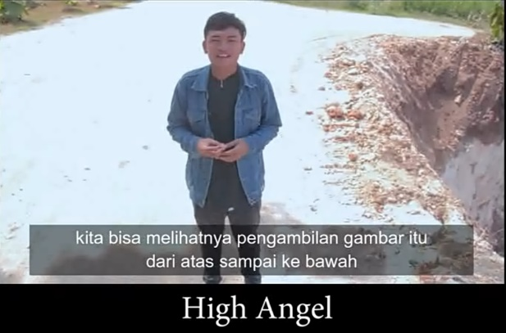
Figure 1. Graph of High Angle

Eye Level
The standard shooting angle, sometimes known as the "Eye View," is parallel to the object's eye. Usually, videos featuring people are shot from this viewpoint. This viewpoint is occasionally used in vacation photography movies that are meant to show people in motion, the feel of a city, or interactions with the natural world (Sitorus dan Simbolon, 2020).
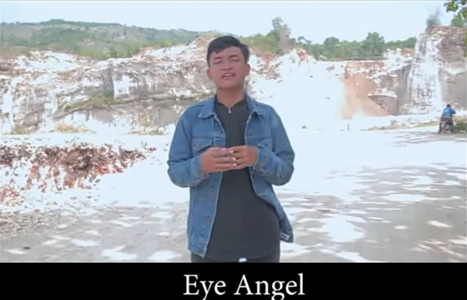
Figure 2. Graph of Eye Level/Eye Angle

Low Angle
Using a low angle means lowering the camera horizontally in relation to the subject of the photograph. Low angle photos are typically utilized to convey a stronger, more powerful, robust, and superior image. Examples of this include people seeming dignified or structures appearing magnificent and substantial (Sitorus dan Simbolon, 2020).
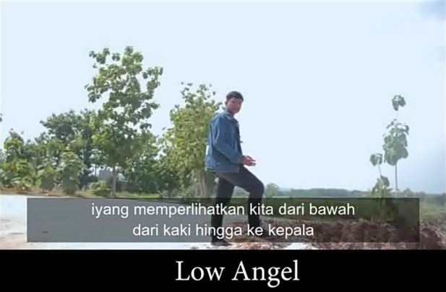
Figure 3. Graph of Extreme Close Up

Type Of Shot
In making educational videos, the cameraman or director needs a type of shot for taking educational videos so that the purpose of taking the shots is in accordance with what is desired. Type of Shot Such as Big Close Up, Close Up, Medium Close Up, Medium Shot, Knee Shot, Long Shot, Very Long Shot, Extreme Long Shot (Sari and Abdullah, 2020).

Big Close Up
Big Close Up are sharper than Close Up, which may show the intensity of a person's stare, their hate of someone, and their emotions. Big Close Up already understands the meaning of a person's reflex or spontaneous reaction without the need for intonation or narrative. One illustration would be a puppet item.


Figure 4. Graph of Big Close Up

Close Up

Taking close-up photos involves capturing the object's whole face in the image. The backdrop of the picture is barely visible as the object takes center stage in the picture. When describing a person's feelings or reactions, a close-up picture composition that centers on the face is the most effective. typically used to display little items in detail, such as the face, hands, or feet. Close-up photography is used to convey the feelings and responses of the subject. The topic will take up virtually all of the frame, making it look quite dominant (Ma’rufi, Anwar & Putra, 2023).
Figure 5. Graph of Close Up

Medium Close Up
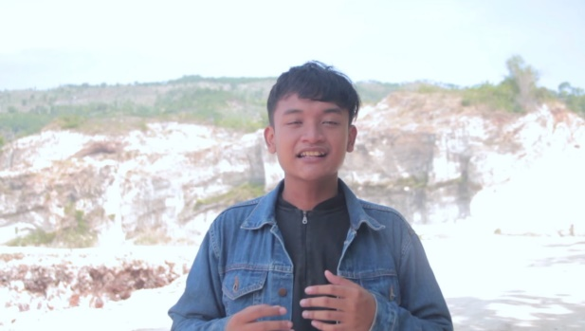
From the object's torso to the top of its head, medium close-up images are included. A composition for a half-body portrait that yet allows for some backdrop flexibility is called a Medium Shot. The Medium Shot enhances the image by displaying the captured object's profile. The actor's body portion is visible from the chest up at this medium close-up distance. The topic will take up most of the frame. In situations where the scene is a typical chat, medium close-up is used (Ma’rufi, Anwar & Putra, 2023).
Figure 6. Graph of Medium Close Up

Medium Shot
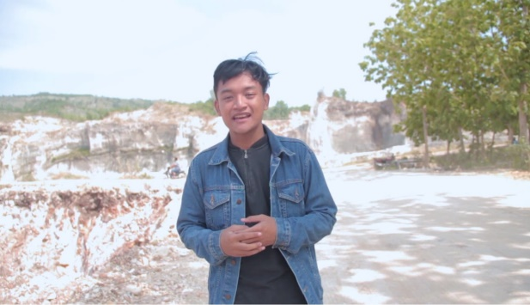
From the head to the hips, shots are included in this shot. For interviews, this picture frequently serves as the ideal arrangement. where the emotions and facial expressions of the interviewees are visible to all viewers. A medium shot is one in which the backdrop is still visible but the subject of the photo is starting to come into focus. This method of filming highlights the human figure from the waist upwards. The most common kind of shot utilized in movies is this one (Ma’rufi, Anwar & Putra, 2023).
Figure 7. Graph of Medium Shot

Knee Shot
The picture Knee Shot (Medium Long Shot) has a human object's measurements from head to knee. Knee shots are frequently employed to enhance an image's appeal. The human body is captured from the knees up in a medium long shot, maintaining equilibrium with the surroundings. This further distinguishes the medium shot from the long shot type (Ma’rufi, Anwar & Putra, 2023).
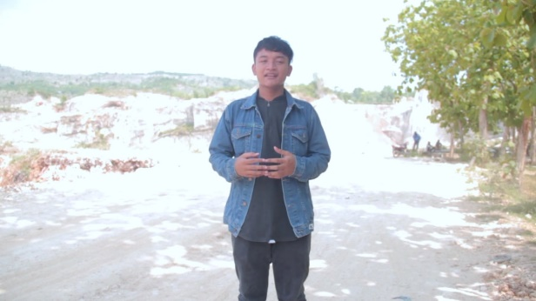
Figure 8. Graph of Knee Shot

Long Shot
This view captures the full image of an item, seen from head to toe, or the entire person. The landscape format known as "Long Shot" draws the viewer's attention to the scope of an item and atmosphere. Long shot distance makes the actor's entire body more visible, yet the background of the subject remains prominent. The goal of using a long shot is to maintain the subject's clarity in the center of the frame (Ma’rufi, Anwar & Putra, 2023).
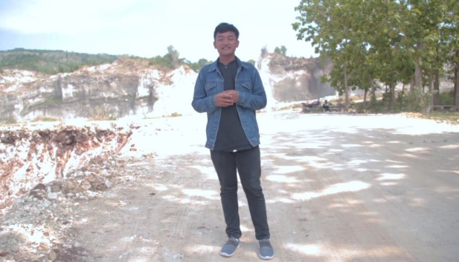
Figure 9. Graph of Long Shot

Very Long Shot
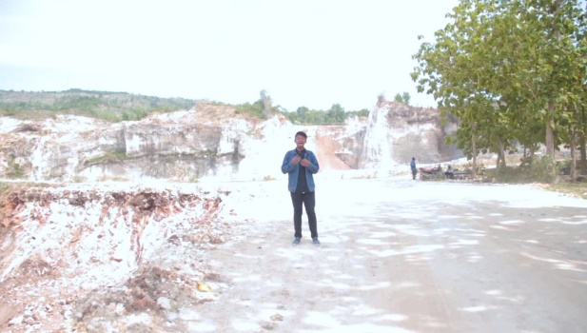
Shots that portray things like massive cities or landscapes are categorized as Very Long Shots. Objects are displayed 1/3 bigger than they are in the extreme long shot.
Figure 10. Graph of Very Long Shot

Extreme Long Shot
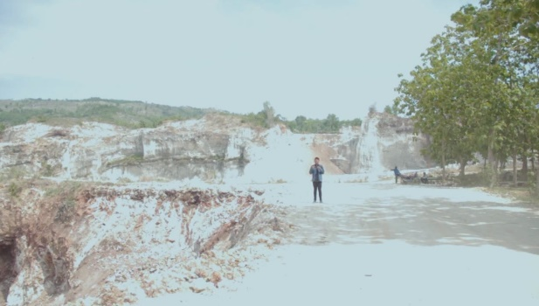
An event or a view that is extremely far away, lengthy, and large in dimension can be produced with the use of an extreme long shot picture size. Extreme Long Shot is typically employed to create stunning panorama picture compositions. The kind of camera angle that is farthest away from the subject it is capturing is called an extreme long shot. At the position of the photo, the object will seem little. This kind can be employed to draw attention to the object's position and give the impression that it is far away (Ma’rufi, Anwar & Putra, 2023).

Figure 11. Graph of Extreme Long Shot

CONCLUSION
The conclusion of this study is that making educational videos requires shooting techniques from the shot type and camera angle. because in making educational videos, researchers often find that educational video makers do not follow the rules of shot type and camera angle. In the future, there needs to be training for teachers or students in making educational videos using the rules of shot type and camera angle so that the message conveyed to the audience is conveyedThe conclusion of this study is that making educational videos requires shooting techniques from the shot type and camera angle. because in making educational videos, researchers often find that educational video makers do not follow the rules of shot type and camera angle. In the future, there needs to be training for teachers or students in making educational videos using the rules of shot type and camera angle so that the message conveyed to the audience is conveyed.

Reference
Amir, D. R., Ulfia, N., & Muktamir, M. 2024. Exploration of Easy Ways to use Green Screen in Making Learning Videos in Information Technology Education Study Programs. Jurnal Pendidikan Edutama, 11(1), 167-178. http://dx.doi.org/10.30734/jpe.v11i1.4070
Amir, D. R., Zahroh, F. S., Puspitanigsih, S., & Fawaid, M. I. 2023. Efektifitas Penggunaan Wodershare Filmora dalam Editing Video Pada Pembelajaran Pengantar Teknologi Informasi. In Prosiding Seminar Nasional Pendidikan FPMIPA (Vol. 1, No. 1, pp. 306-313).
Ardianto, D. T., Irfan ilIsma, A., Wicaksono, A. R., Mataram, S., & Herlambang, R. W. (2021). Teknik Green Screen Dalam Pengembangan Video Pembelajaran Di Era Pandemi Covid 19. Brikolase: Jurnal Kajian Teori, Praktik dan Wacana Seni Budaya Rupa, 13(2), 59-69.
Irawan, A., Sihkabuden & Sulthoni. 2017. Pengembangan Media Video Pembelajaran Biologi Pembuatan Tempe dan Yogurt. Malang: JINOTEP, Volume 3, Nomor 2, April 2017
Ma’rufi, M. L., Anwar, A. A., & Putra, W. T. G. (2023). PENATAAN KAMERA FILM FIKSI< PESAN SINGKAT= TENTANG PERAN GENERASI MUDA TERHADAP KRISIS REGENERASI PETANI DI KECAMATAN ARJASARI KABUPATEN BANDUNG. eProceedings of Art & Design, 10(2).
Parwanta, D. N., Santiyadnya, I. N., & Arsa, I. P. S. (2021). Pengembangan Media Video Pembelajaran Green Screen Berbasis Adobe Premier Pro Pada Mata Kuliah Audio Video Editing Di Program Studi Pendidikan Teknik Elektro. Jurnal Pendidikan Teknik Elektro Undiksha, 10(3), 131-141.
Ruslan, R. 2020. Penanaman Pendidikan Moralitas dan Nilai Pancasila Anak Usia Dini dalam Perkembangan IPTEK. Abdimas: Papua Journal of Community Service, 2(1), 11-17.
Samtrimandasari, E. N. A. (2023). Analisis Angle Kamera Point Of View (POV) dalam Membangun Penceritaan Terbatas pada Film “Searching”. Sense: Journal of Film and Television Studies, 6(1), 13-24.
Sapriyah, S. 2019. Media Pembelajaran dalam Proses Belajar Mengajar. In Prosiding Seminar Nasional Pendidikan FKIP (Vol. 2, No. 1, pp. 470-477).
Sari, R. P., & Abdullah, A. 2020. Analisis isi penerapan teknik sinematografi video klip monokrom. Jurnal Riset Mahasiswa Dakwah dan Komunikasi, 1(6), 418-423. http://dx.doi.org/10.24014/jrmdk.v2i1.9236
Sitorus, C. P., & Simbolon, B. R. (2020). Penerapan angle camera dalam videografi jurnalistik sebagai penyampai berita di Metro TV biro Medan. JURNAL SOCIAL OPINION: Jurnal Ilmiah Ilmu Komunikasi, 4(2), 137-150.

